Prototype Connection Techniques
In this section's activity, we learned a bit about the solderless breadboard, which is one of the more popular ways to connect electronic components together when building prototypes. There are several other techniques for connecting devices, and how they might fit into different stages of prototype development.
Solderless Breadboard:
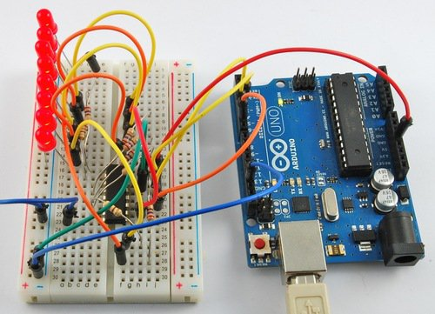 | This board (already discussed in some detail in the activity) has the advantage of being almost effortlessly reconfigurable. If you'd like to change out a device, you just pull it out of the board and plug a new device in. If you'd like to change the way things are wired, you just pull and replace the wires. This is a great way to do the 'proof of concept' stage of a device. The downside is that the device usually isn't very durable since its so easy for a wire or even device to fall out.

Soldered Protoboard:
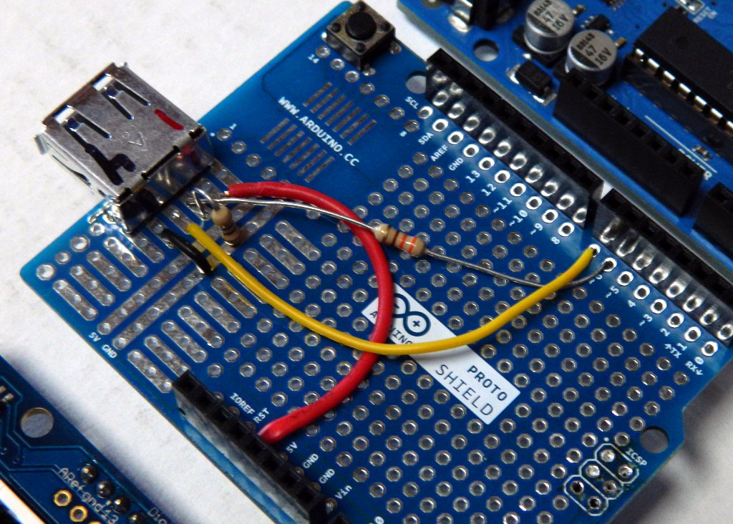 | This device is similar to a breadboard in that it gives you pre-connected rows of pins. Soldering two devices into the same row connects them electrically. Unlike the breadboard, placing a device or wire into a protoboard means soldering it in place. On the upside, this means that the device is much more solid, and you can do things like test it out in the real world without too much concern about snagging a wire or a device falling out. On the downside, it's less forgiving if you make a mistake or decide you want to make changes about how something is placed or wired.

Simple PCB:
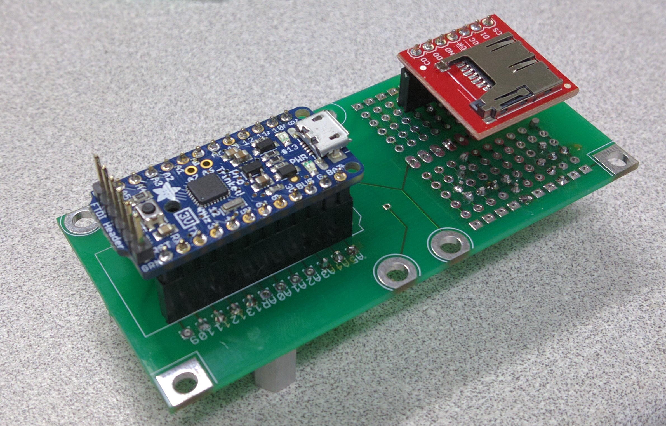 | This device is similar to a breadboard in that it gives you pre-connected rows of pins. Soldering two devices into the same row connects them electrically. Unlike the breadboard, placing a device or wire into a protoboard means soldering it in place. On the upside, this means that the device is much more solid, and you can do things like test it out in the real world without too much concern about snagging a wire or a device falling out. On the downside, it's less forgiving if you make a mistake or decide you want to make changes about how something is placed or wired.

Advanced PCB:
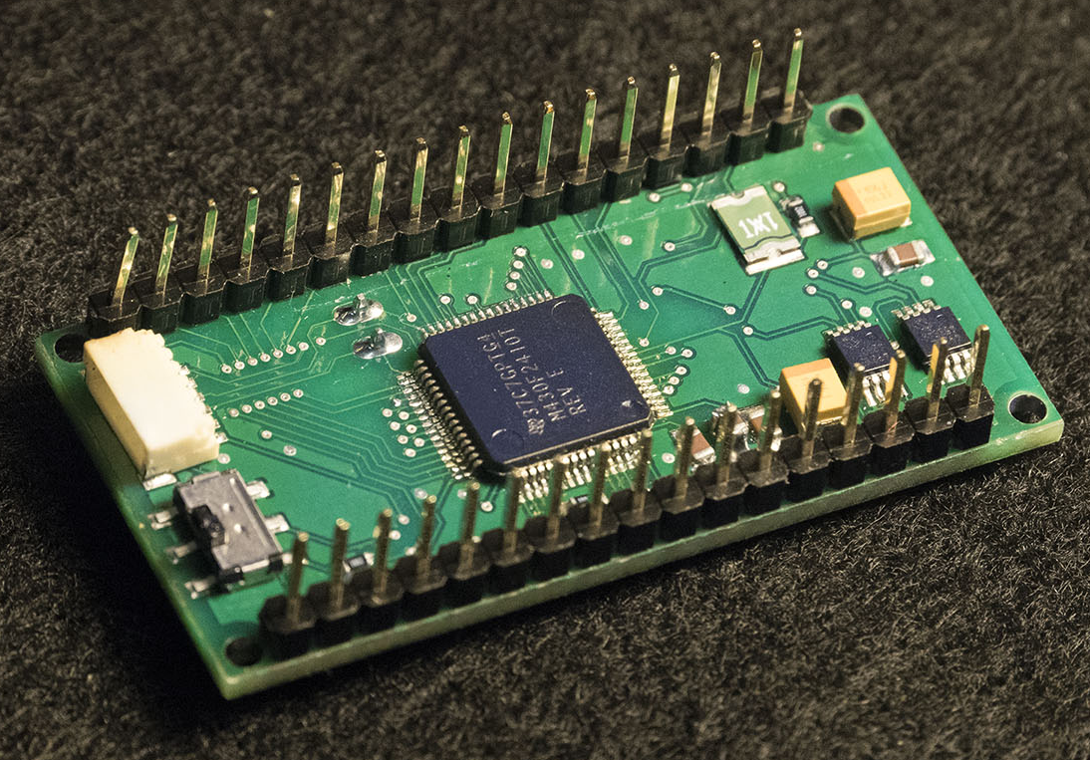 | This is the point where we might stop thinking of the device as a protoype, and start thinking about it as a product. At this point, we are implementing the same manufacturing techniques with which the Adruino and the sensors are built. Instead of parts being connected to the PCB with through-hole soldering, they are done with surface mount micro-soldering. At this step, we might do things like replace the Arduino with a surface mount version of the Amtel Processor it uses, and similarly with the other devices in our prototype. This requires a lot of design work. The end result is a device that can be easily manufacturer in large quantities and will be very cost effective if printed in large quantities.

